Wenzhou Safewire Electric CO.,Ltd.
SPECIFICATION SHEET

PRODUCT NAME: Desktop socket
PRODUCT No.: FZ-515

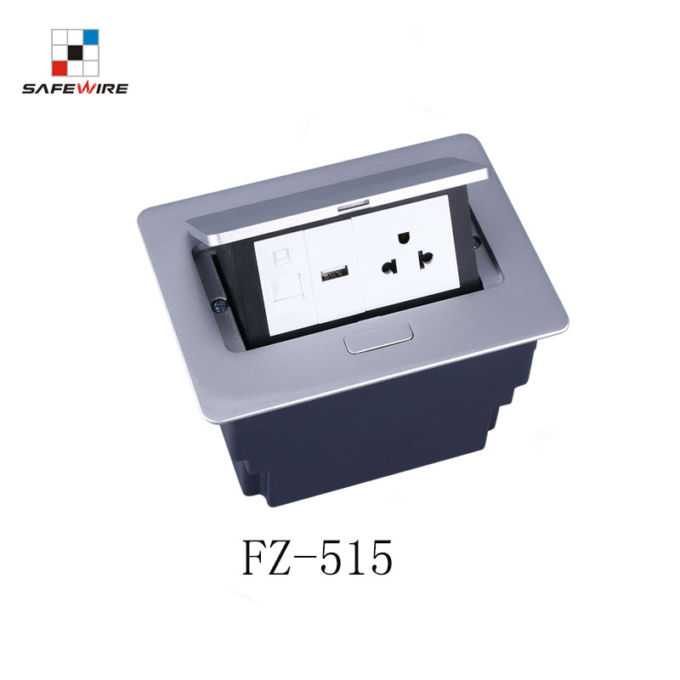
Address:2nd floor, Wealth Garden, Liushi town, Yueqing, Wenzhou,China ,325604
Tel:0086-577-61725369
Mob:0086-18612380398
ZIP:325604
（E-mail）：info@safewirele.com
(WEB): http://www.safewirele.com

Technical parameters & characteristic :
- Working environment:
- The environment temperature:-5℃~/40℃
- The rated voltage：100V~~250V
- Rated current：10A、13A、16A、20A
- Characteristic:
1 | Model | FZ-517 | 6 | HS Code | 8536690000
2 | Brand Name | Safewire or OEM brand | 7 | Market standard | Customized
3 | Type | Desktop socket | 8 | Place of origin | Zhejiang , Wenzhou, China
4 | Color | Silver/black/white | 9 | Frequency | 50Hz~60Hz
5 | Grounding | Standard grounding | 10 | Current Type | AC

- Technical parameters :

Serial No. | Parameter | Description
1 | Material | Zinc Alloy/Steel
2 | Panel Material | Aluminum alloy
3 | Surface finish | Electroplated/Painted/Power sprayed
4 | Panel Dimension(mm) | 170*123
5 | Cutout(mm) | 148*115
6 | Height of product(mm) | 97.6
7 | Bottom box size(mm) | 146*113*95
8 | Bottom box material | Plastic
9 | Capacity of modules /Interface size | 4 ways 45*45mm modules
10 | Configuration | Power outlet+Data outlet or USB charging : Customized as required
11 | Cable length | 1.5m, 2m,2m or required length
12 | Available modules | 45*45mm Type series

Application:
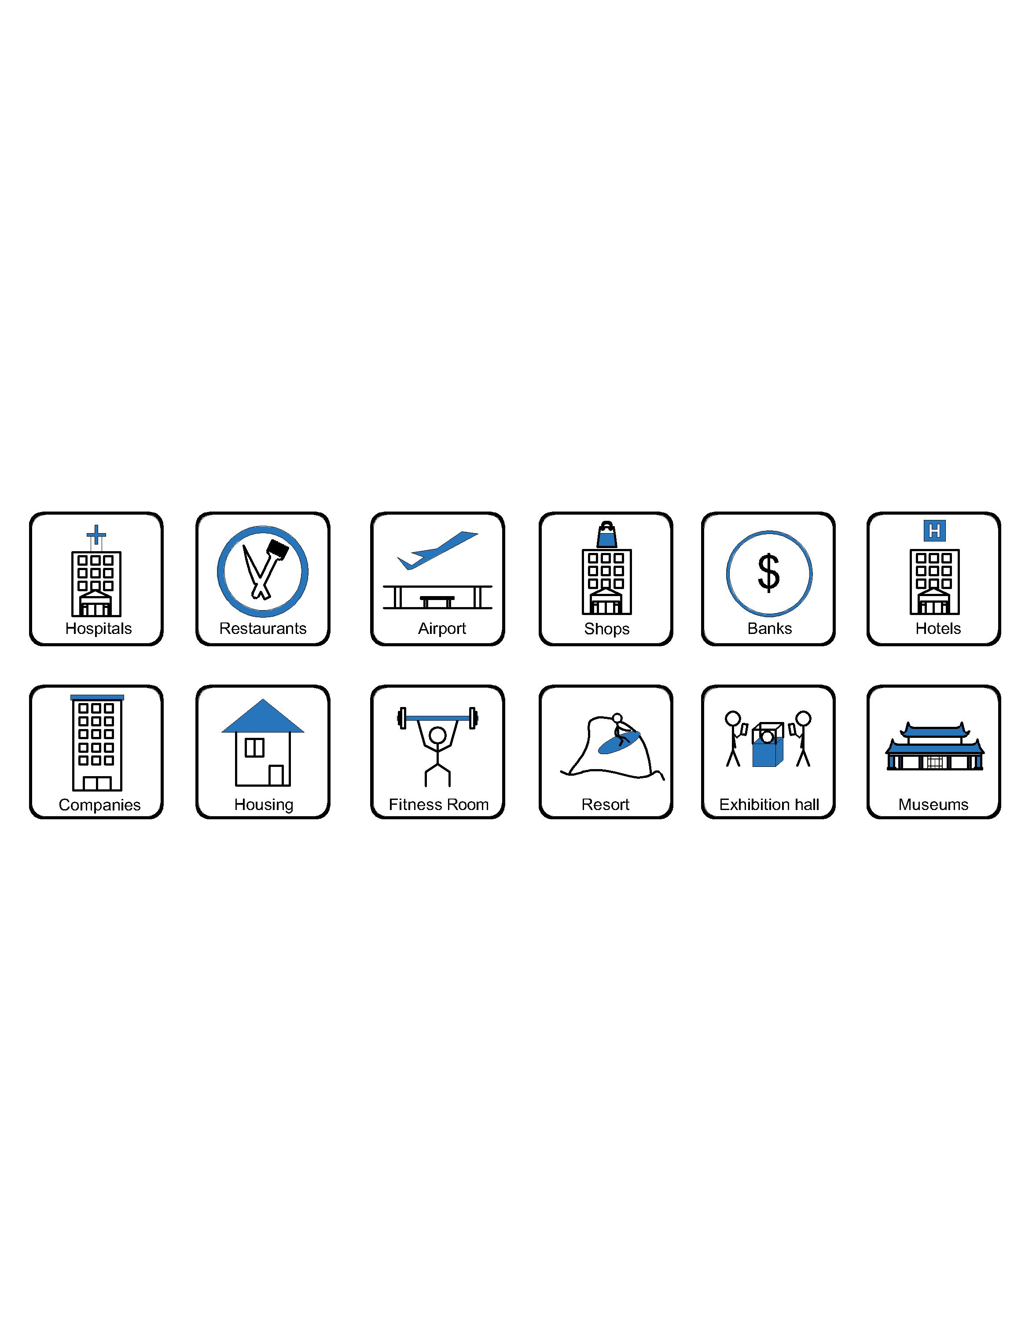
- Office and education
- Industry and Engineering
- Presentation and retail;
- Orientation and safety;
- Transit areas and parking;
- Hotels, hospitality and wellness;
- Health, sport and leisure;
- Art and culture;
CE certificate by TUV,Germany
LVD test report

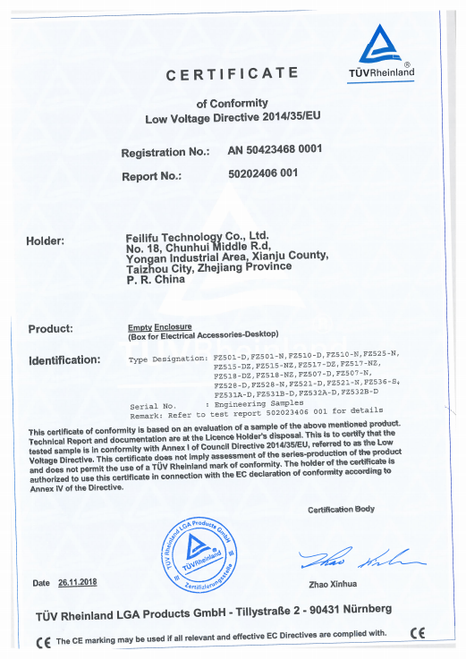
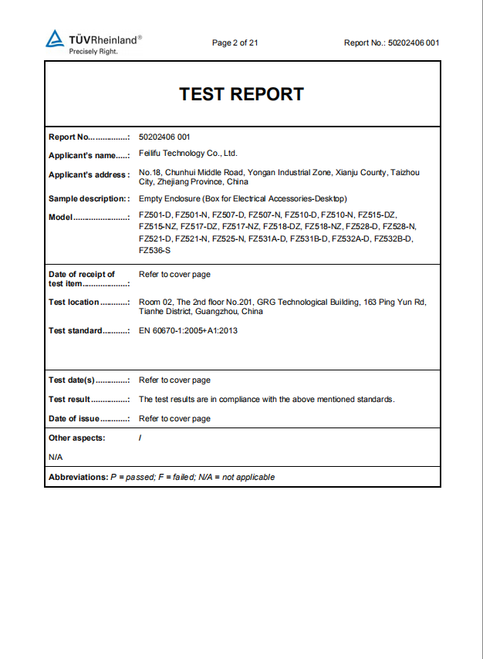

Product Show:
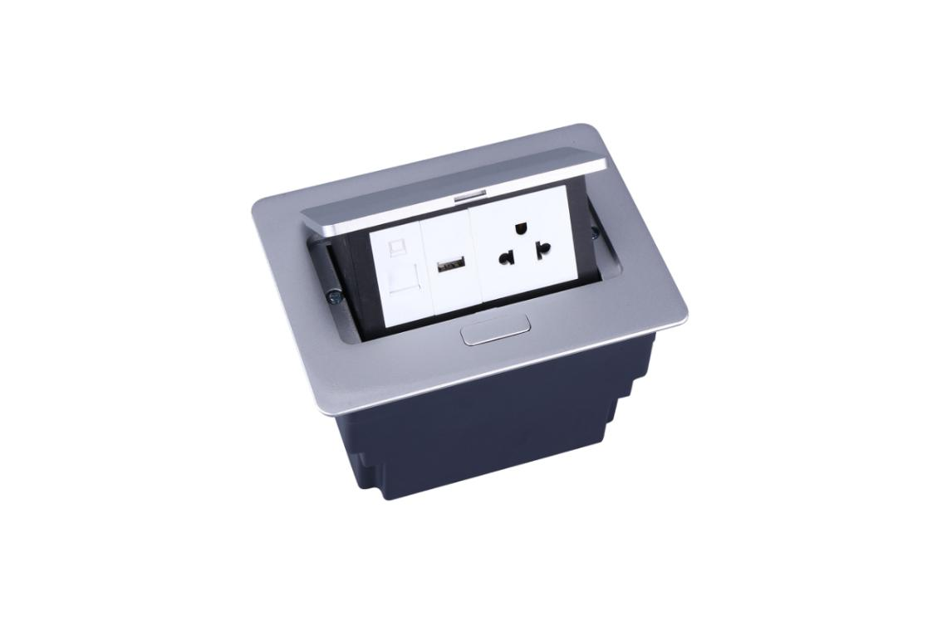
Features:
- With damping device, press button and pop up with slow speed;
- With screws and complete plastic bottom box,more easy to installation;
- The panel is by aluminum alloy of integrate diecasting structure, more reliable surface protect from scratch ;
- Silver or black painting finish of optional surface .

Available for 45*45mm type international sockets or modules types:
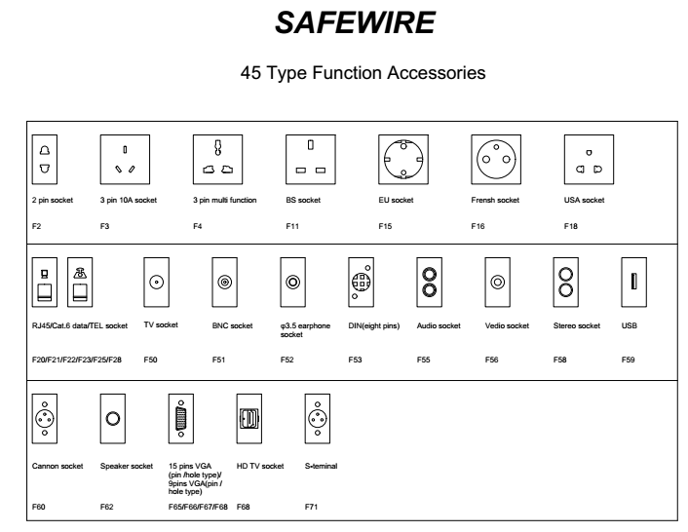

FZ-515 Outline drawing:
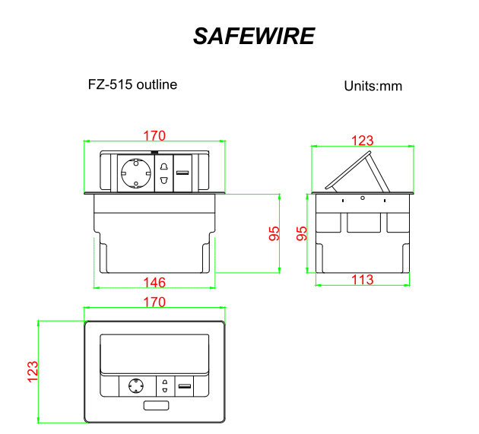
Package:20 Pcs inner box into a master carton.Poly bag with box packing.
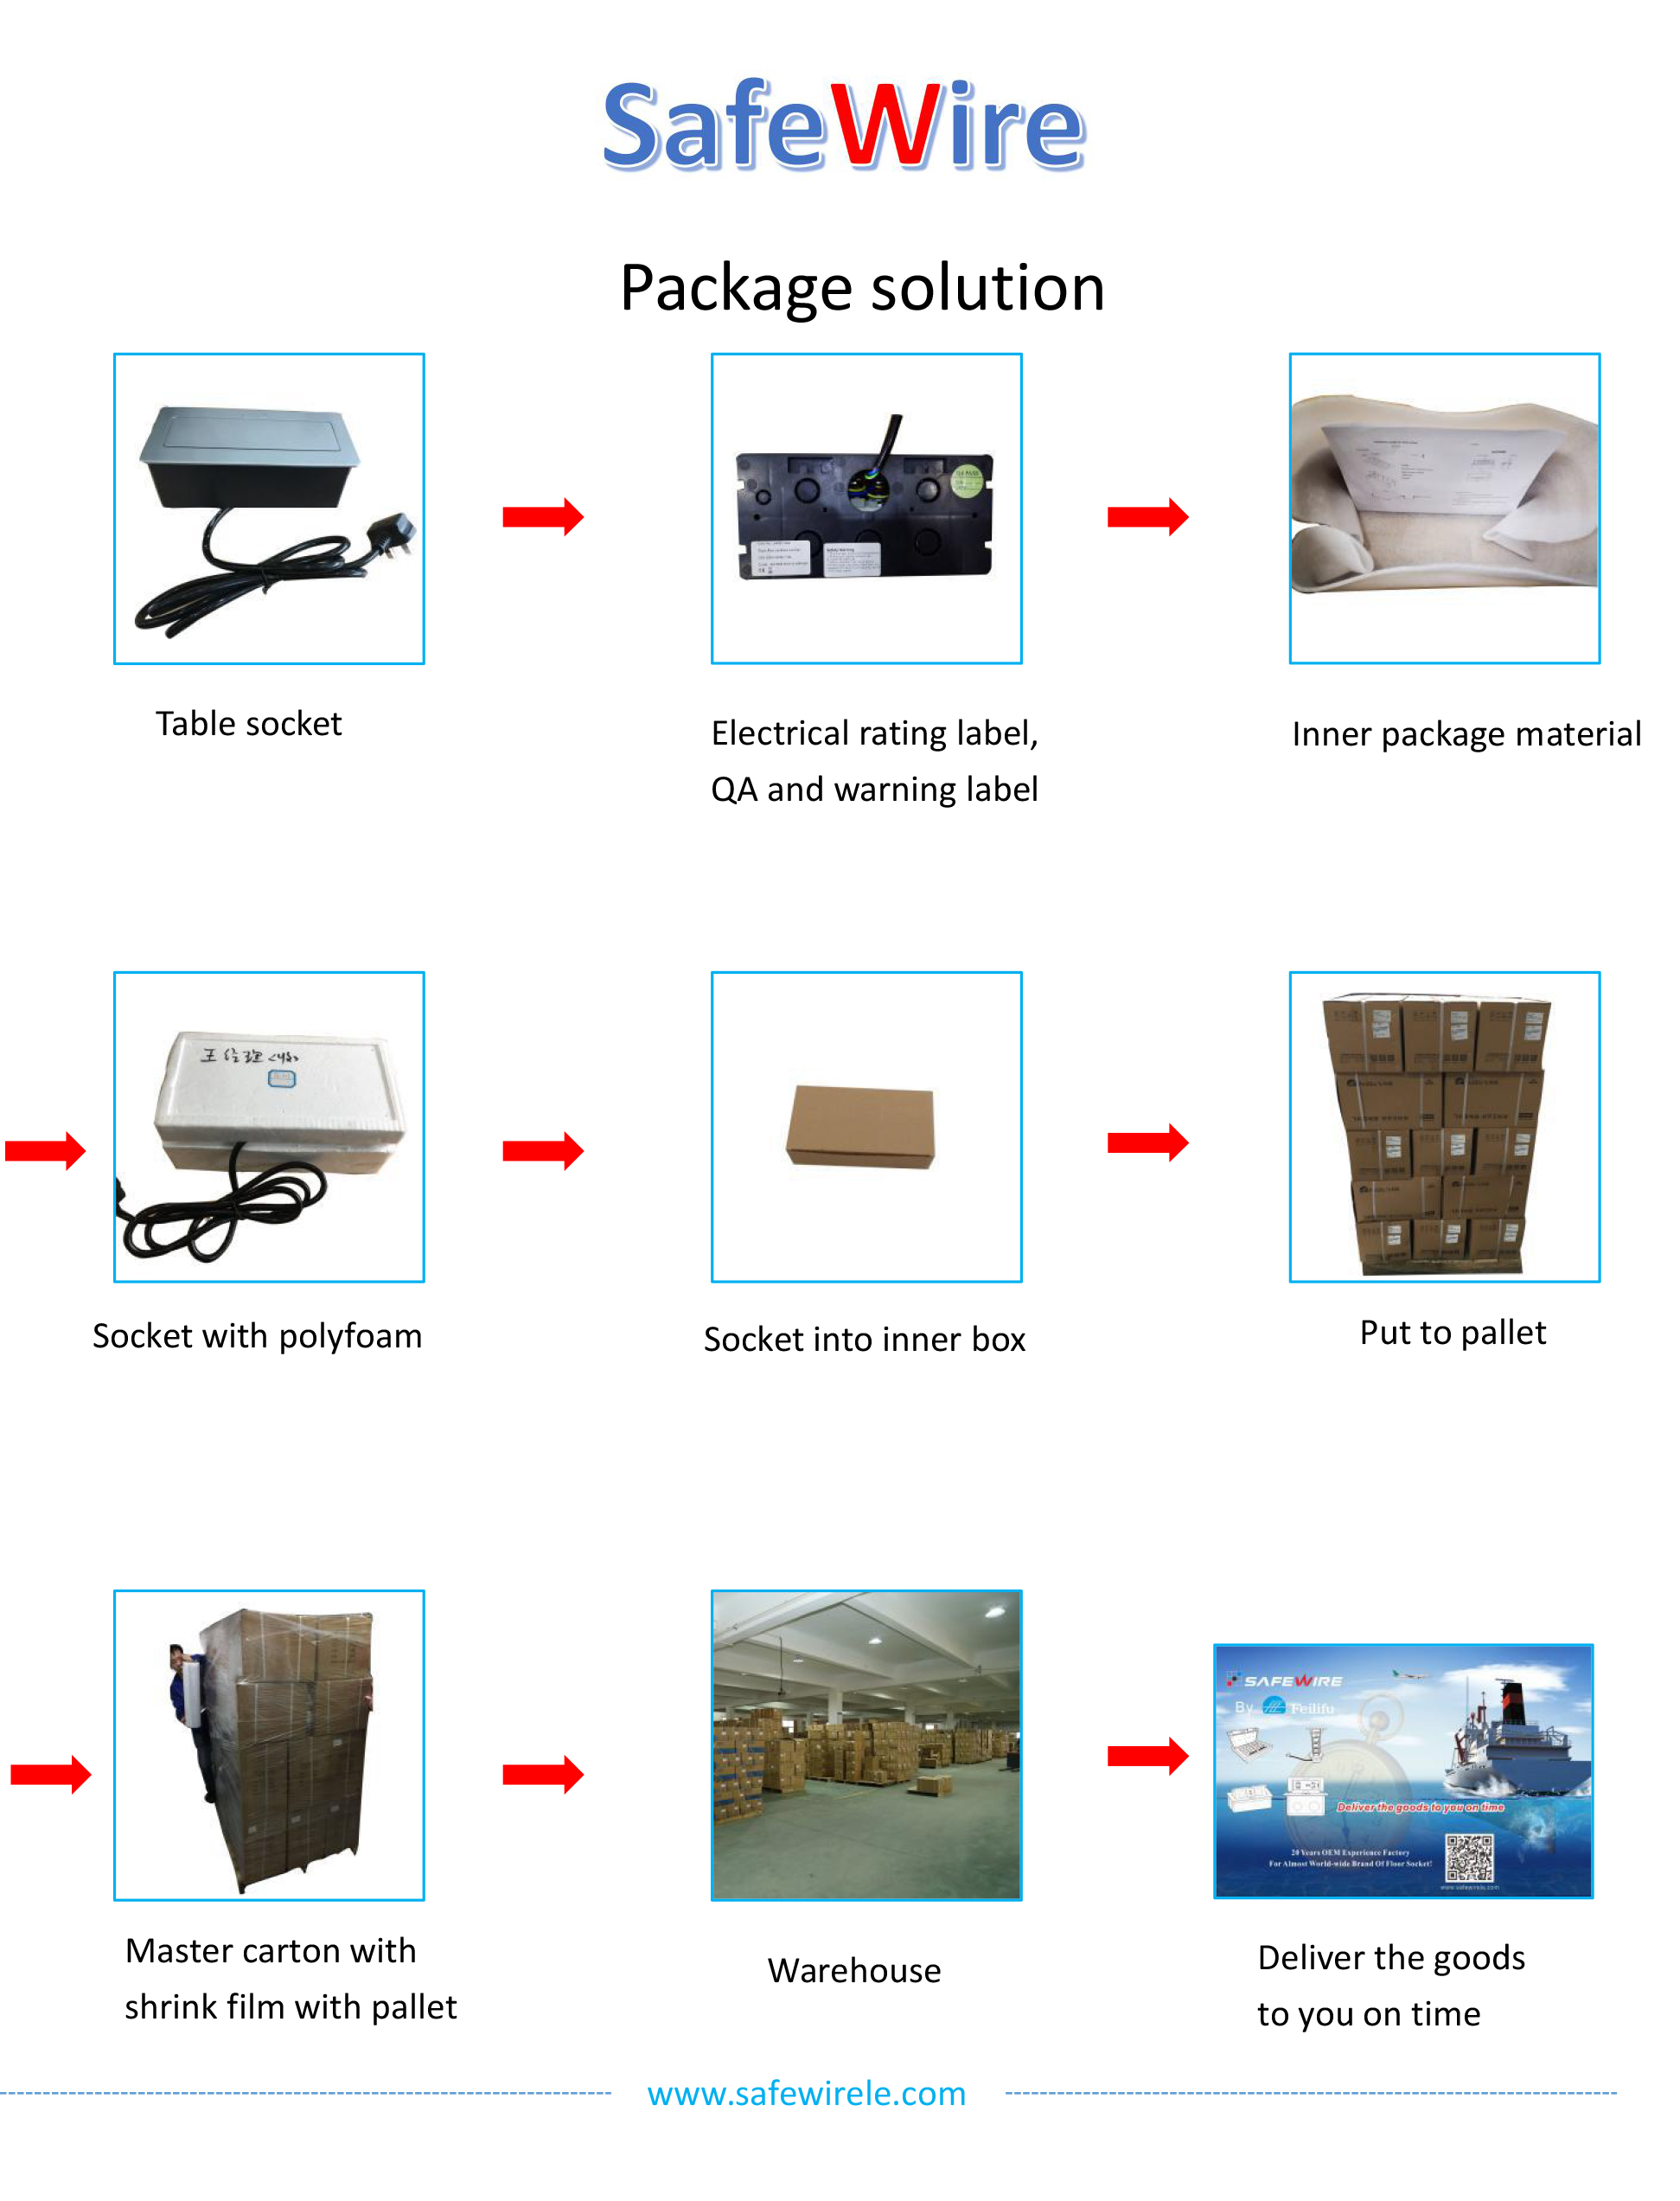

Installation Process

- Cut out as specification sheet.
- put the bottom box into cut-out hole,punch the self-tapping screw and fix the bottom box.
- Remove plastic frame fixing socket modules.Assembly the socket or data Jack into the plastic frame and press frame ensure them combine tightly.
- Keep socket modules connected by inner wire (it should be copper core 1.5mm²9~20 wire and length should be suitable).Then earthing and ensure inner wire tightly with modules.For fast connector terminal block,Just insert wire into block.
- Phone line ,TV receiving line sound box wire（it should thin wire）Just the wire length and tighten stop screw comathen.
- Put the panel on the bottom box and it with the hole.

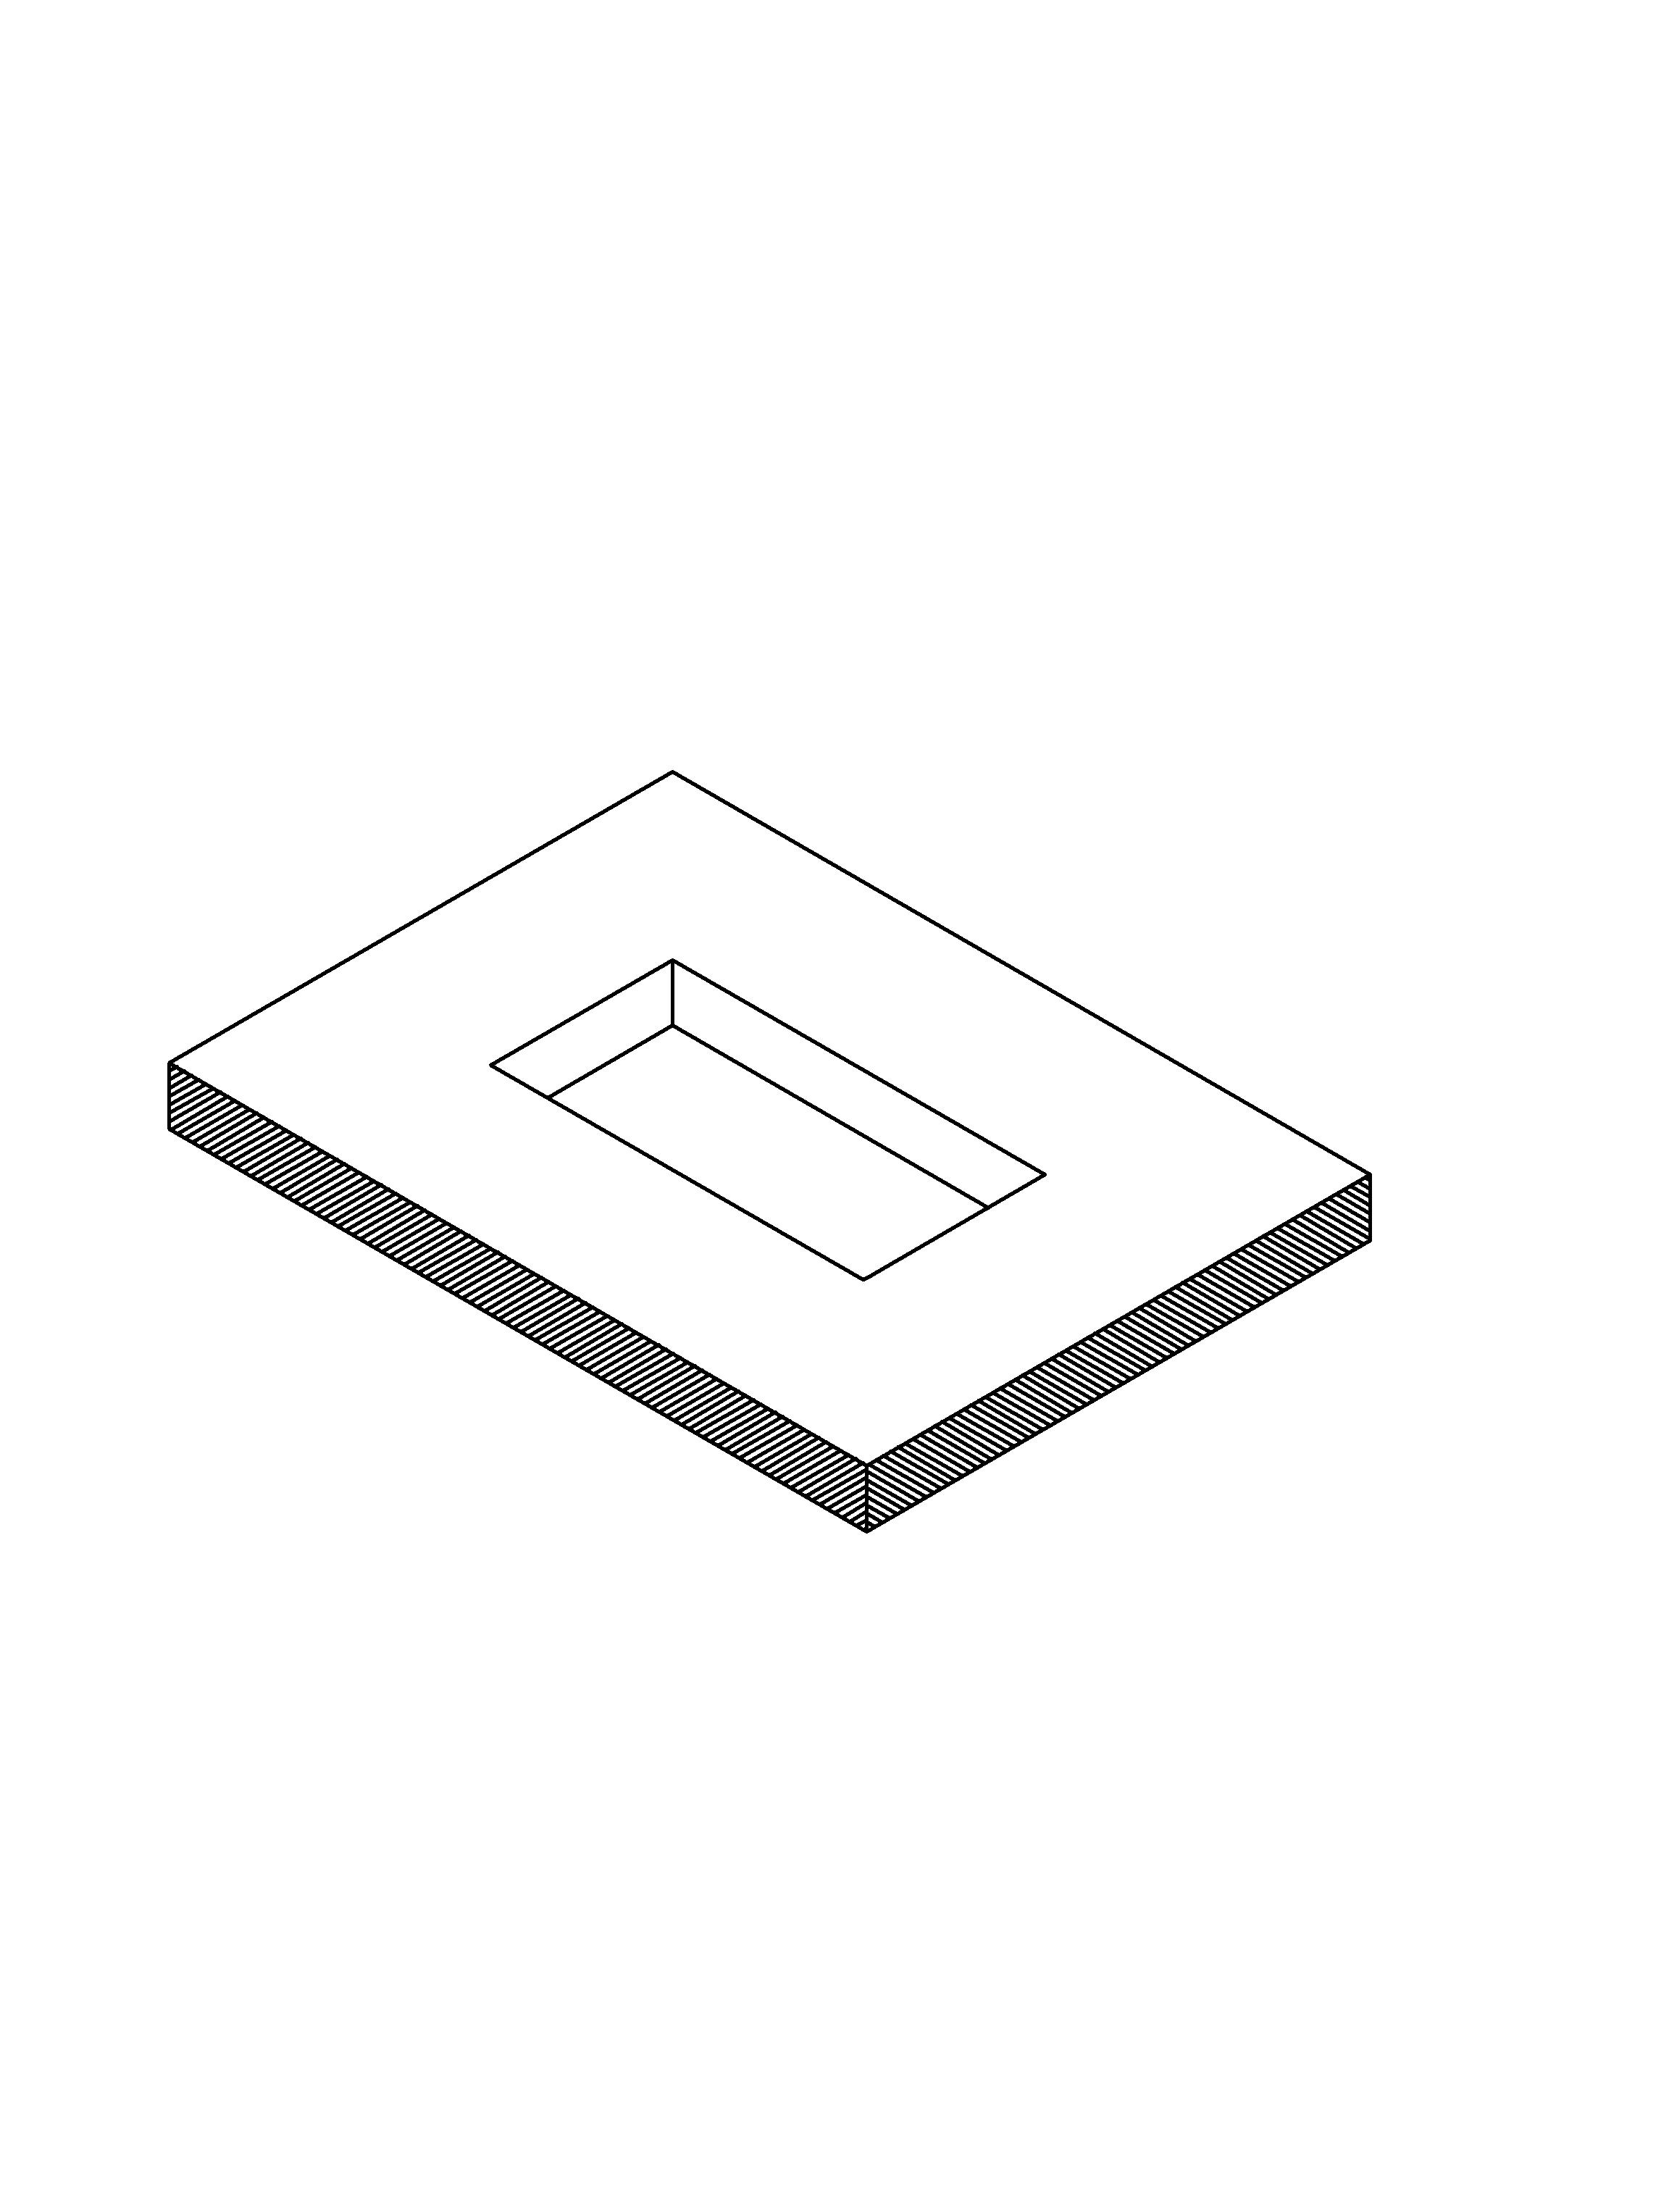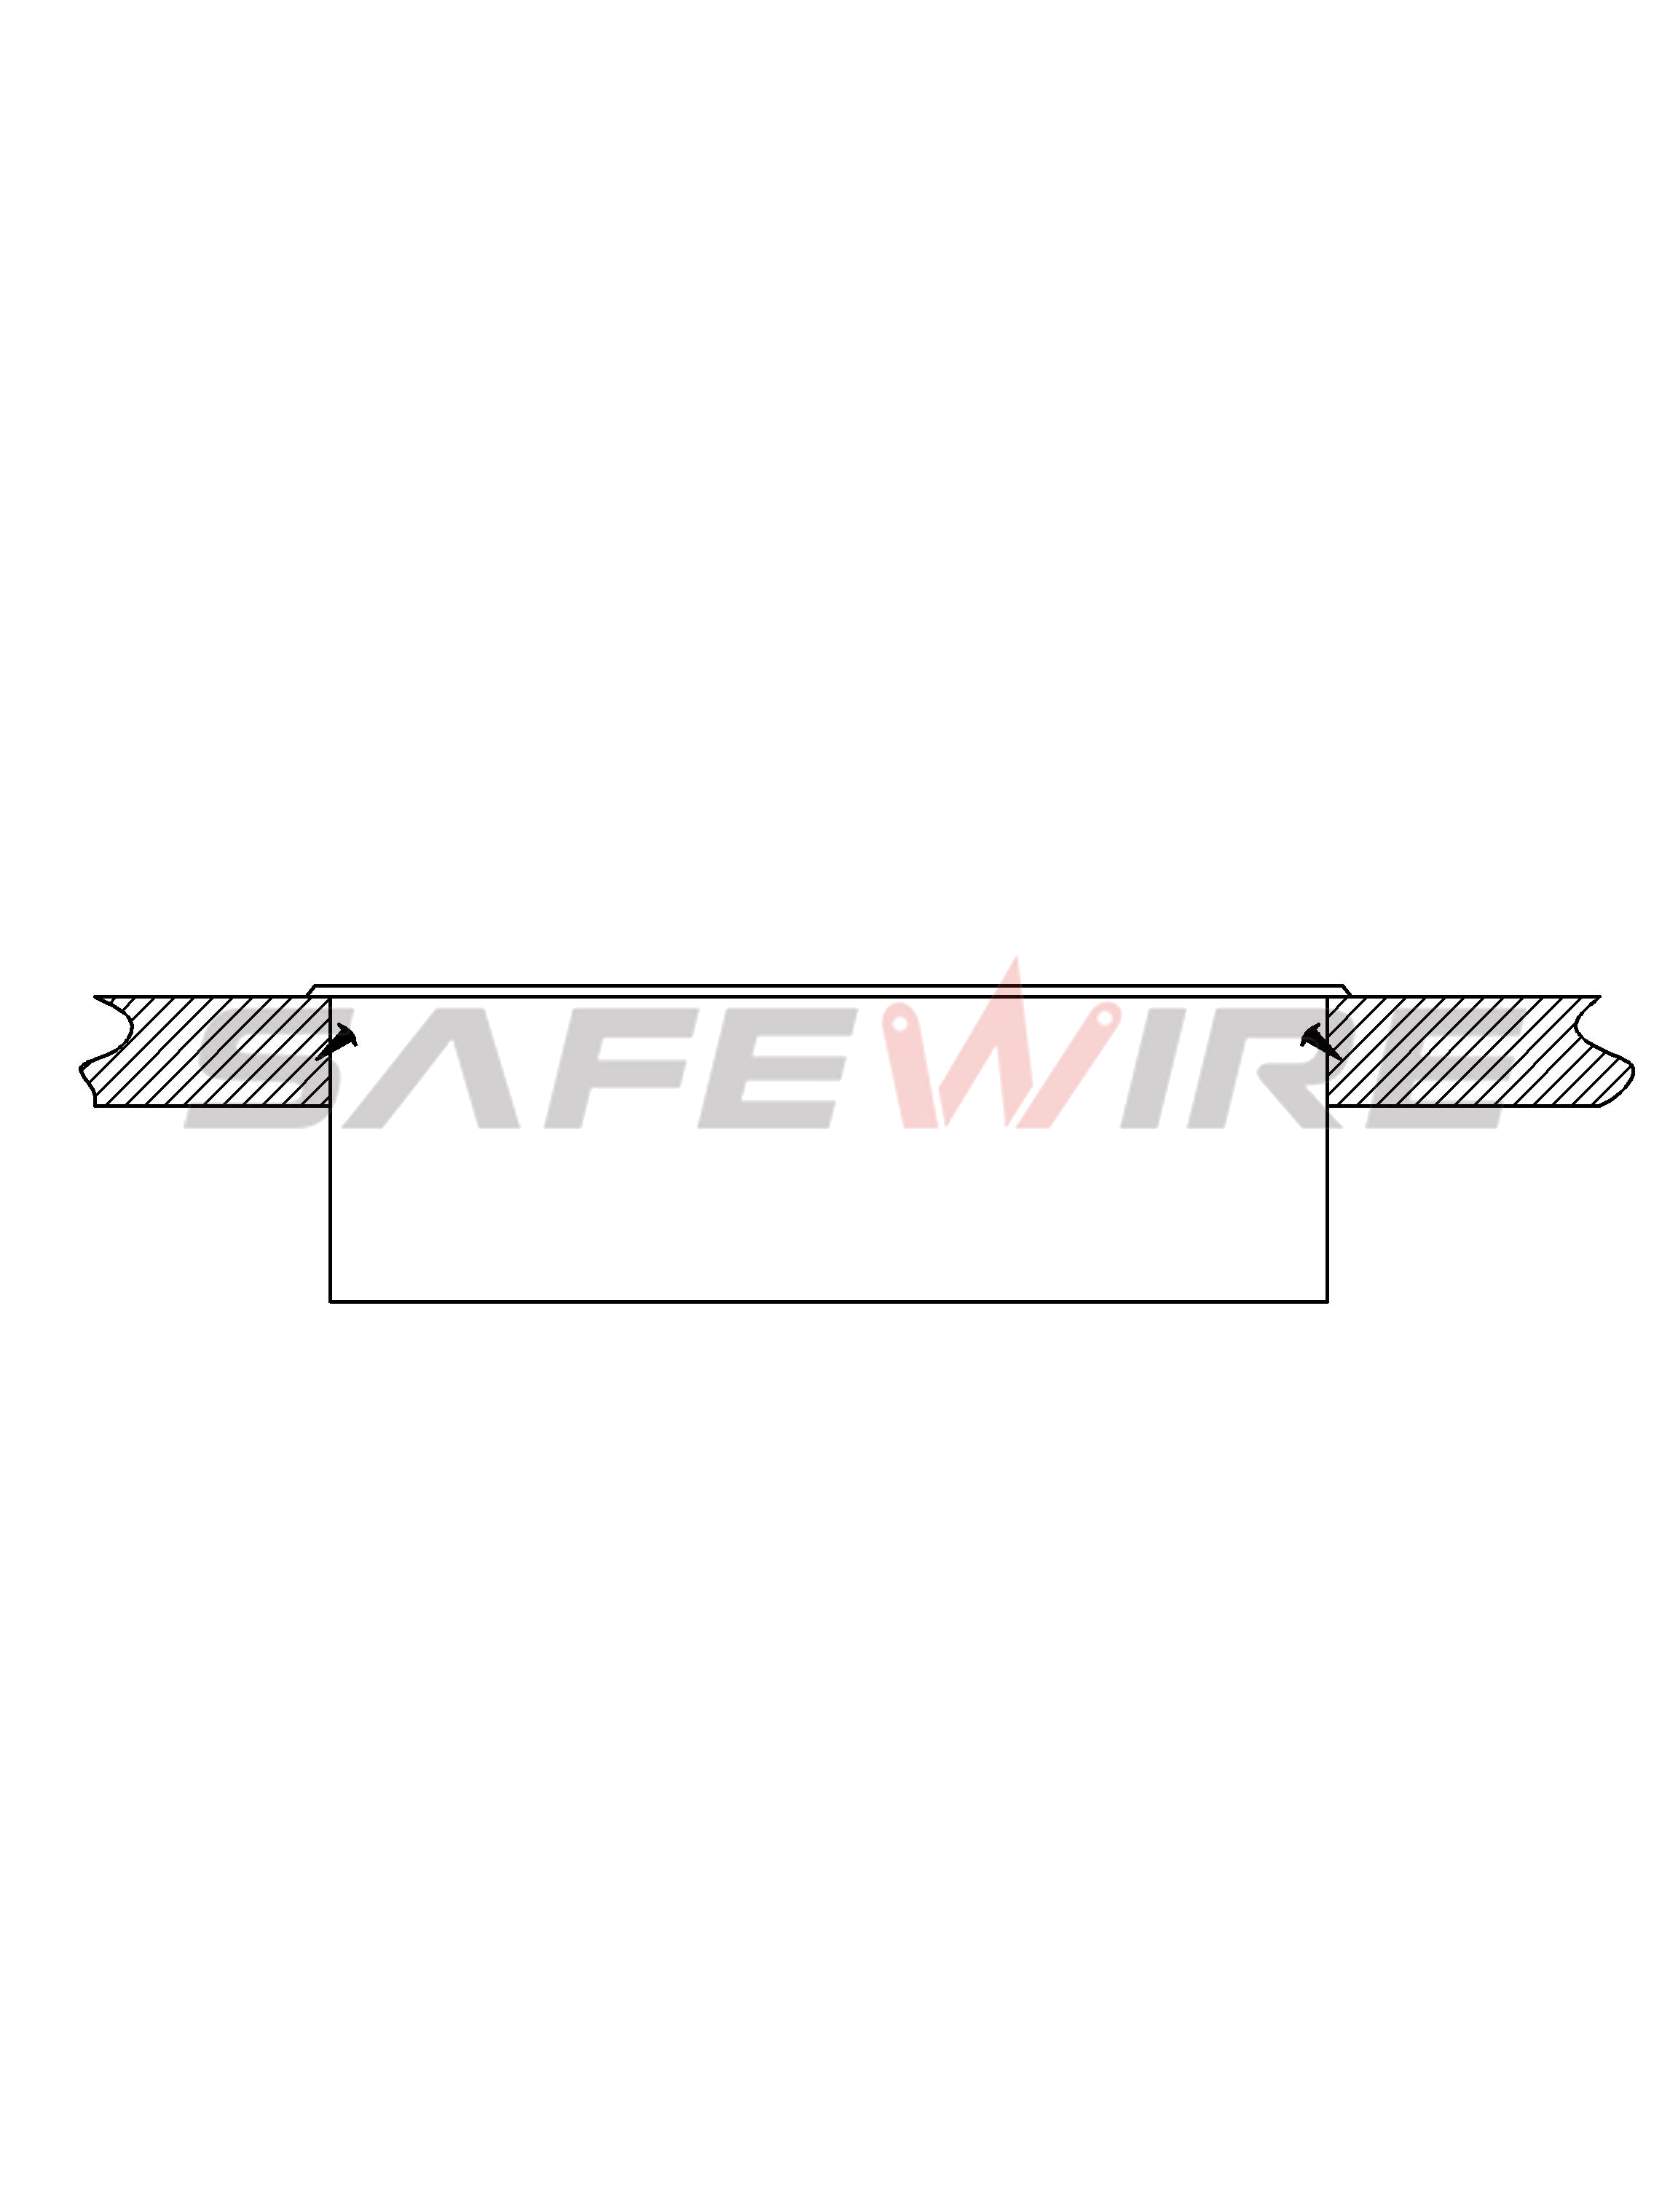
（1）
（2）

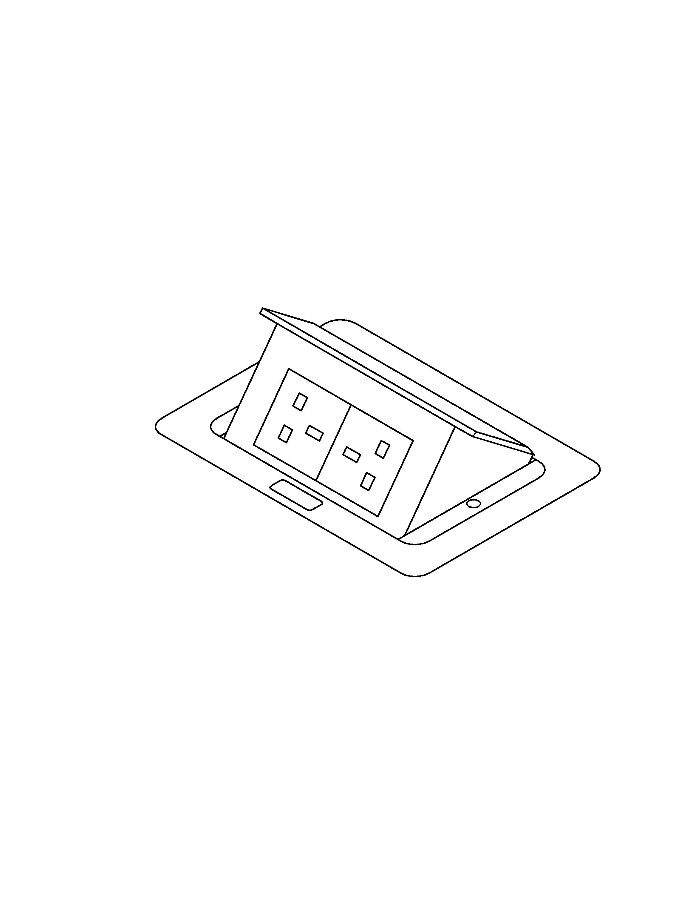
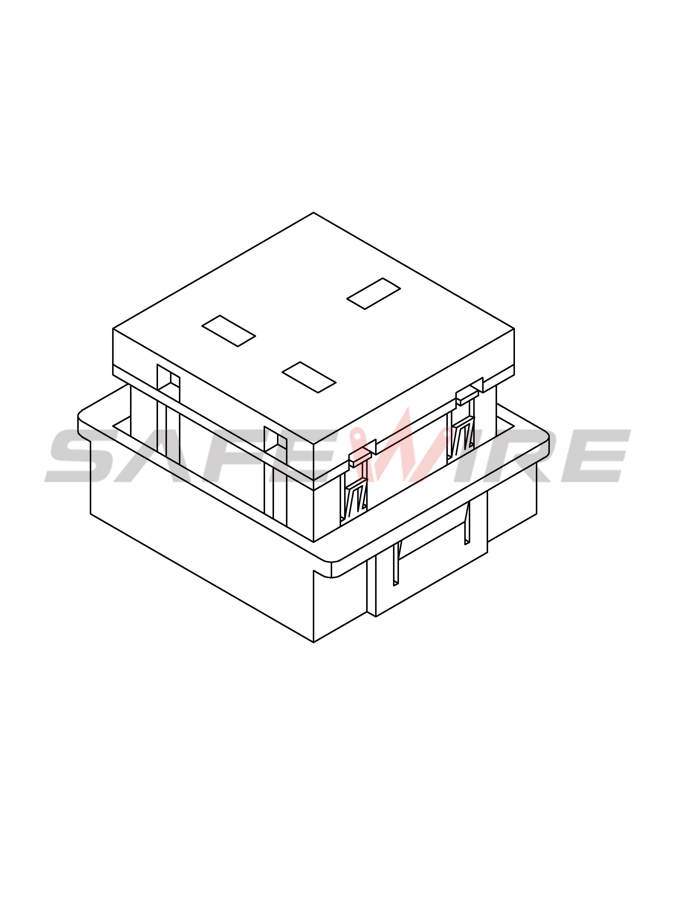
（3）
（4）

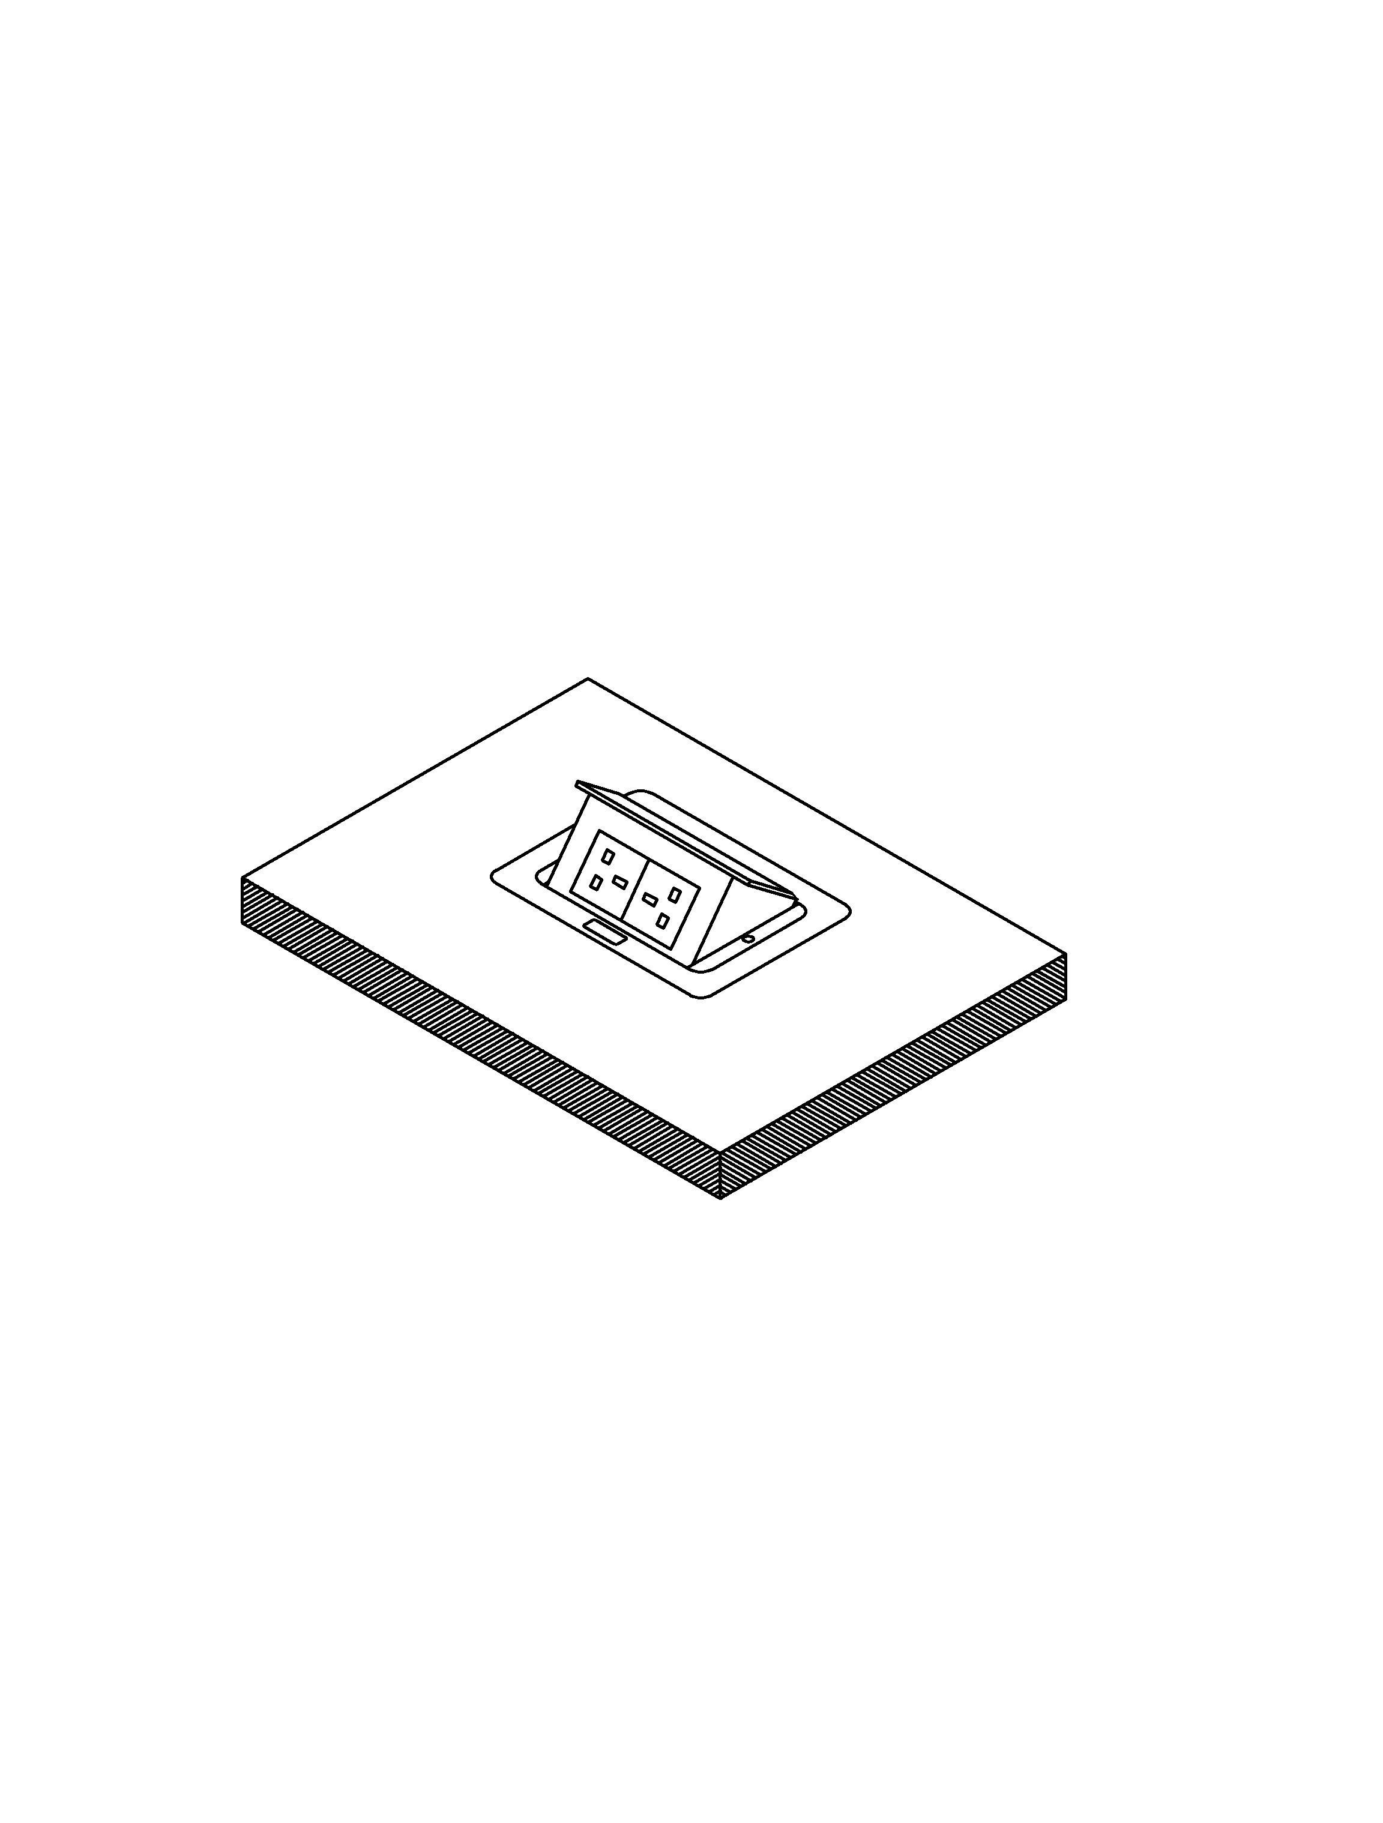
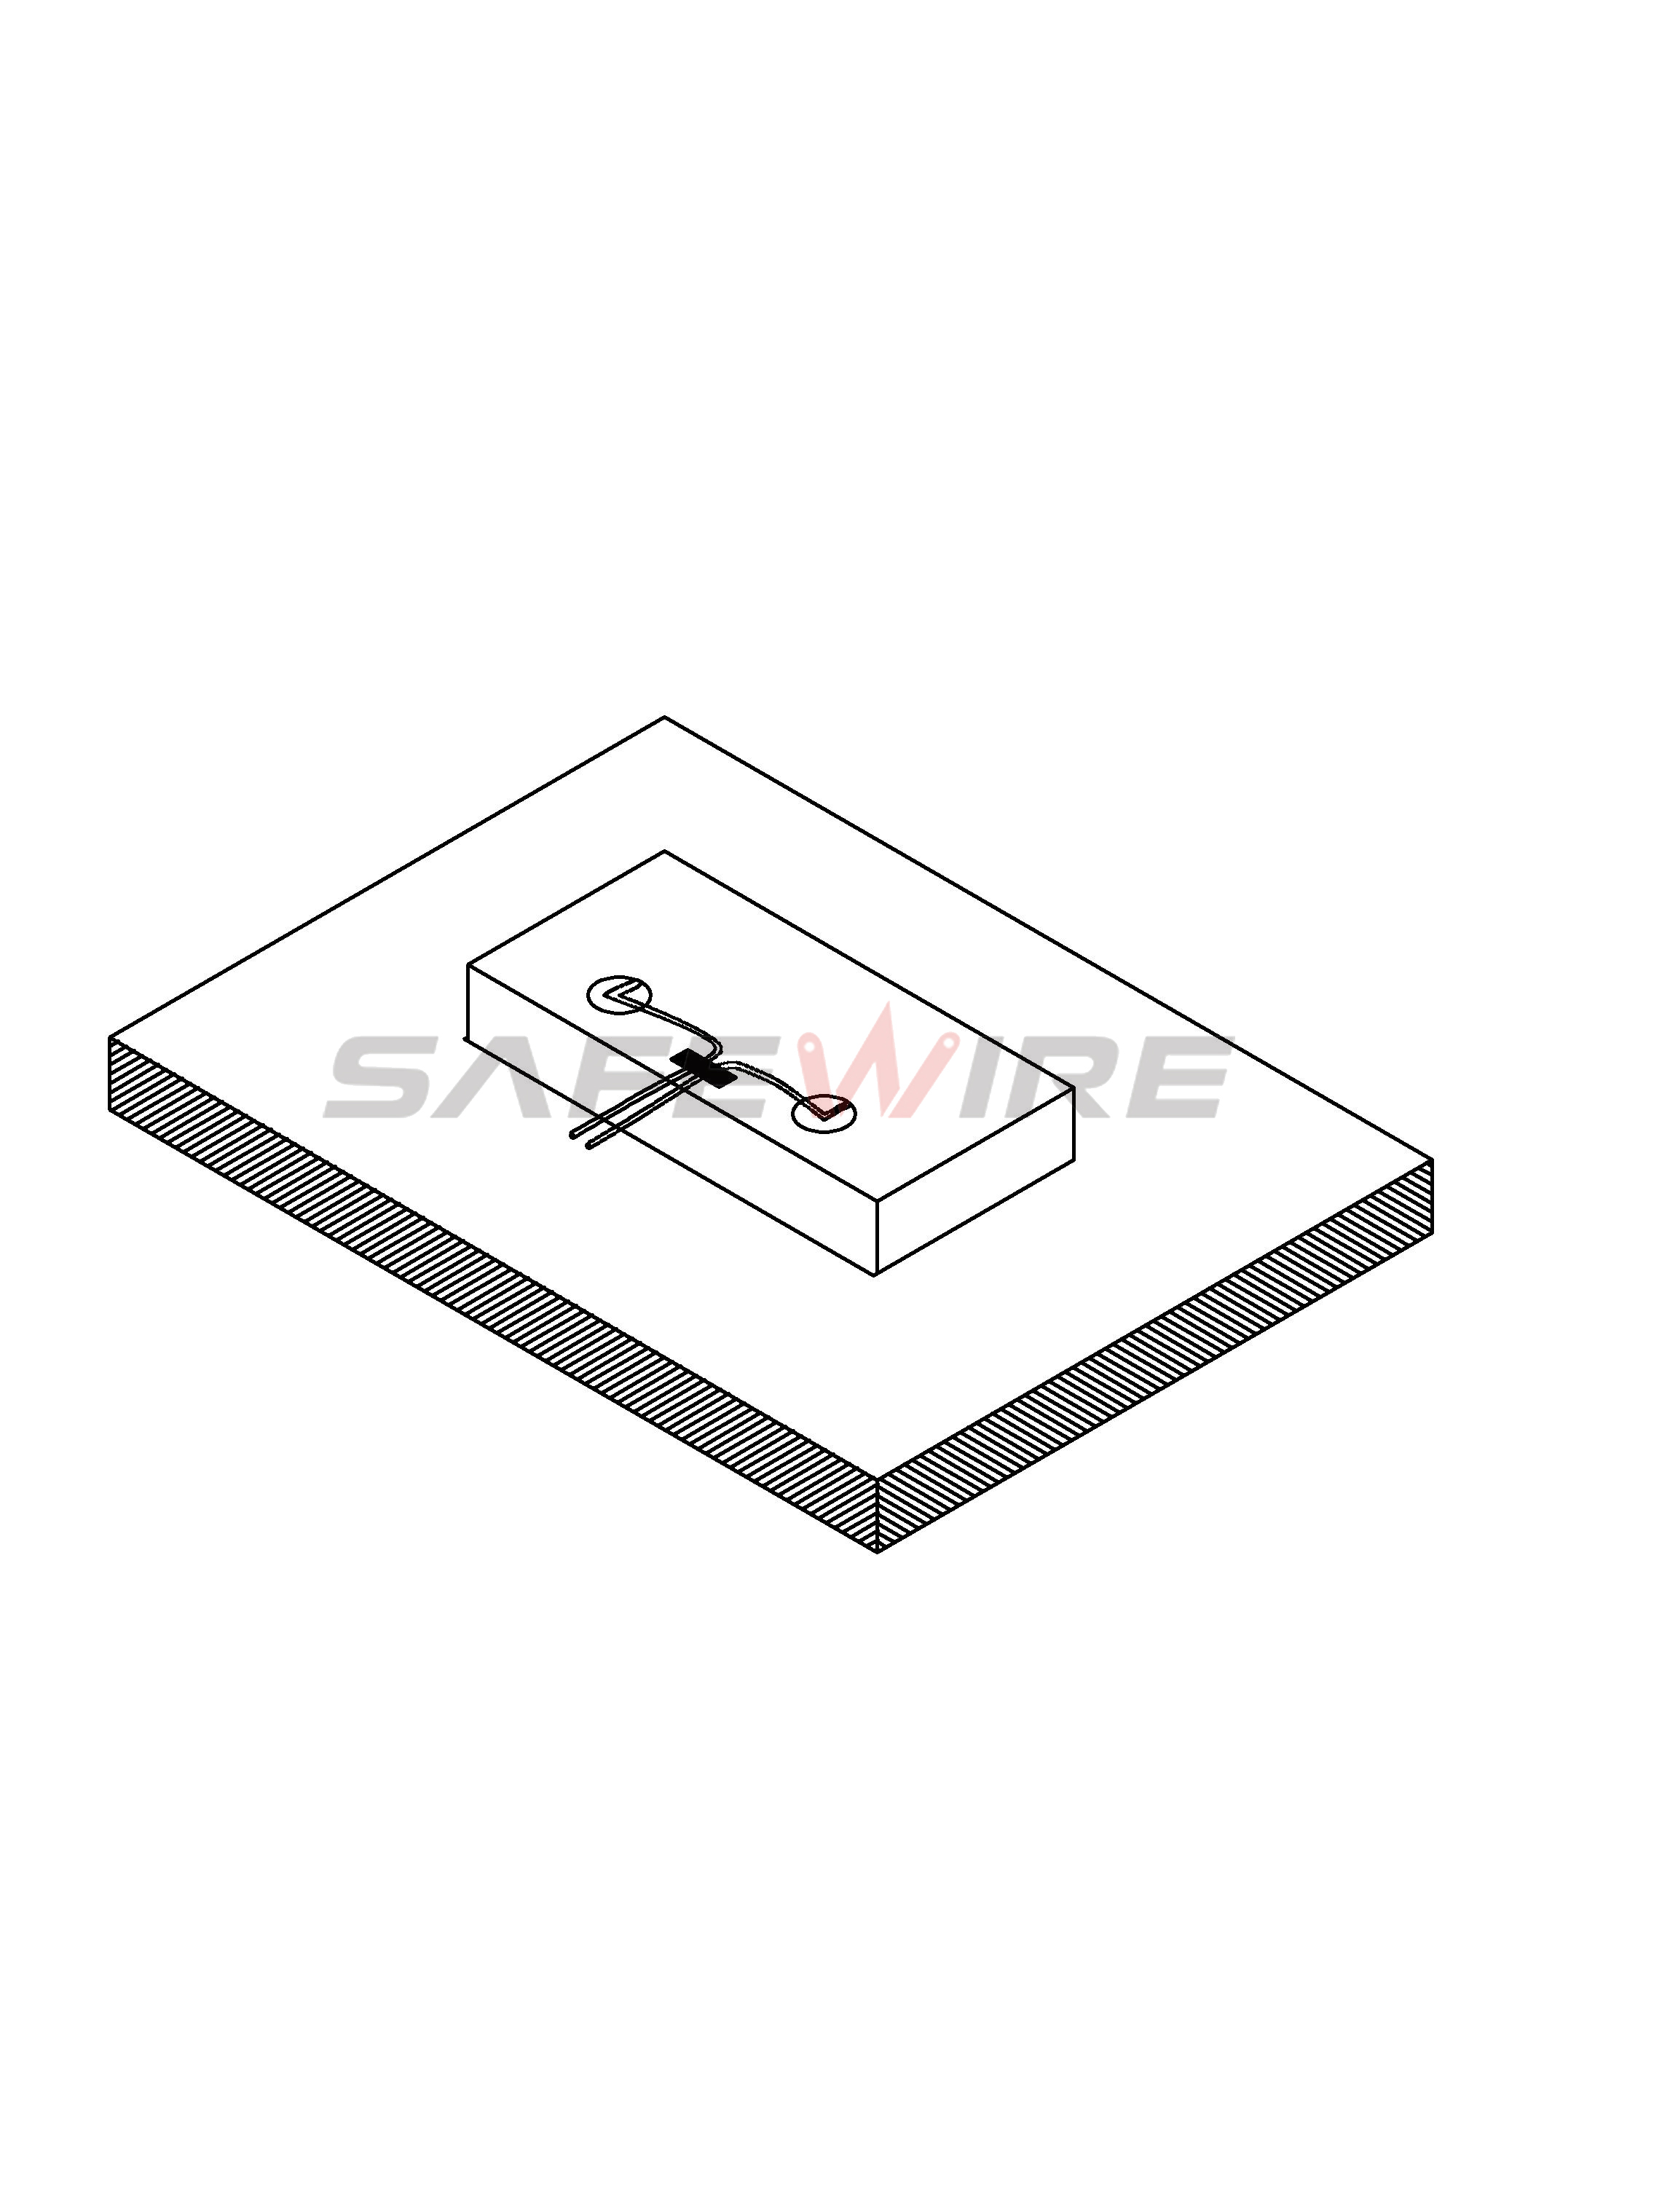
（5）
（6）


Screw
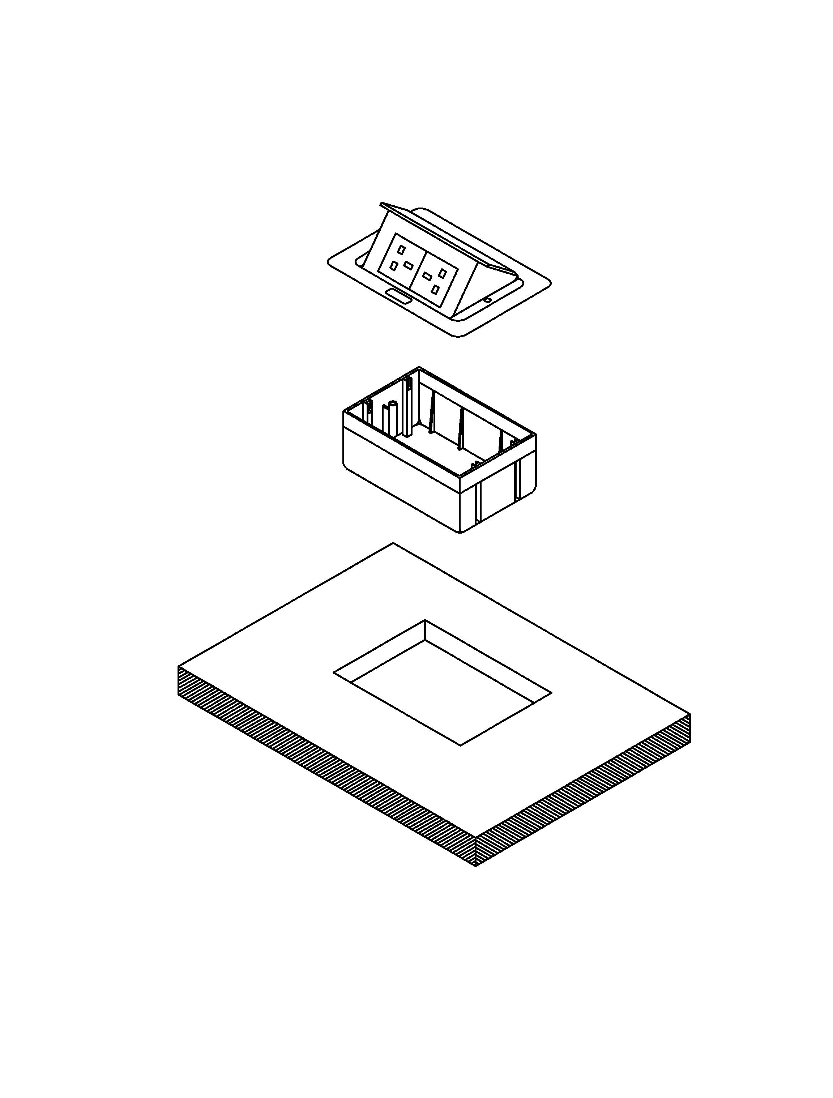
Body and Module
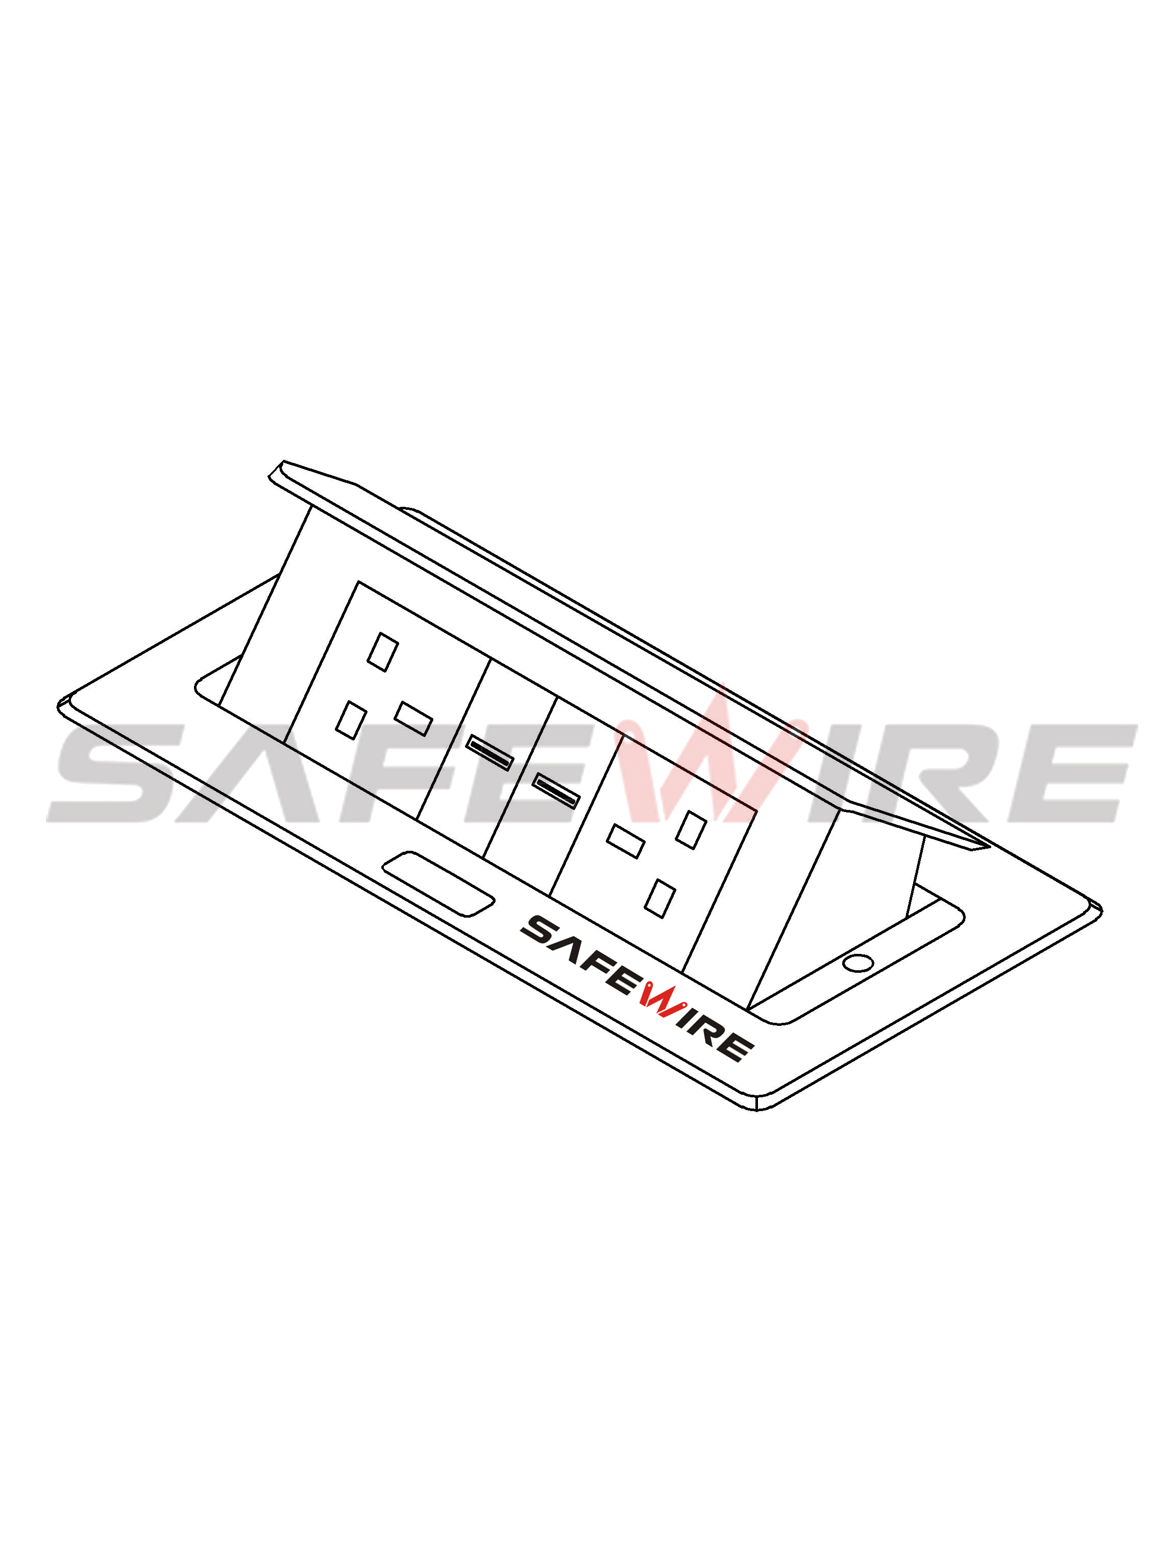
Screw
Base box

Table

(Image is for reference only.)

Attentions:
1.Prevent from corrosive liquid, gas (strong acid, strong alkali, paint)and humidity.
2. All dimension quoted are nominal only. Drawings , images and text are for illustrative perposes only and product details and dimension are subject to change without notice.

Safety Warning:
1)This is a class I product and must be earthed
2)This product must be installed/wired by a qualified electrician
3)before installation/maintnance ,ensure the mains supply is switched off and the circuit fuses are removed or circuit breakers switch off
4)For indoor use only

